Project Demonstration

1. Project Overview & Walkthrough
- What it Does: PocketSmart is an AI-powered budget planning application that helps users dynamically allocate budgets for specific life events (Home furnishing, Parties, and Jewelry) using Google Gemini.
- Core User Journey:

    - Authentication: Users register/login securely with hashed credentials and JWT cookie sessions.
    - Dashboard: Upon logging in, users view their personalized dashboard showing recent activity and session status.
    - Planners: Users enter specific constraints (e.g., party guest count, home fixture numbers, or jewelry outfit preferences) and receive a tailored, itemized breakdown.
    - History: Users can revisit past recommendations stored securely in their history logs.

2. Visual Demonstration & Screenshots
Figure 1: Landing & Login Page
- Description: The clean, modern authentication interface where users sign in or register.

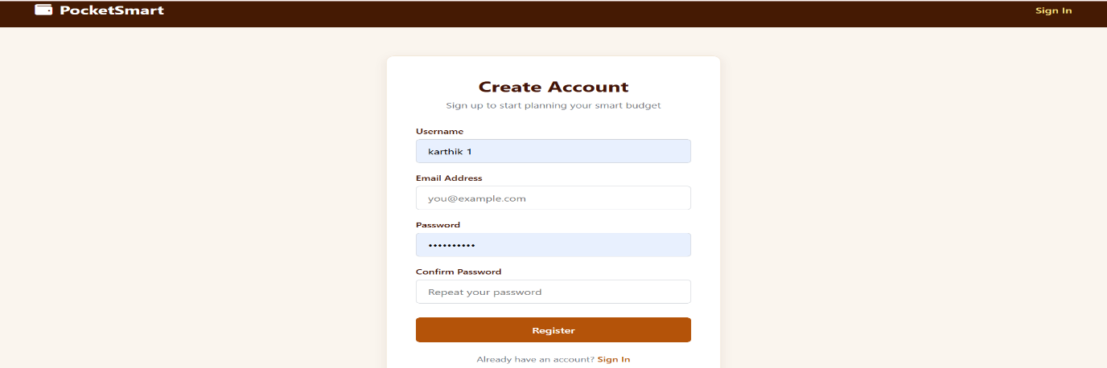
Figure 2: User Dashboard & Planners
- Description: The main hub displaying options for the Home, Party, and Jewelry budget planners.
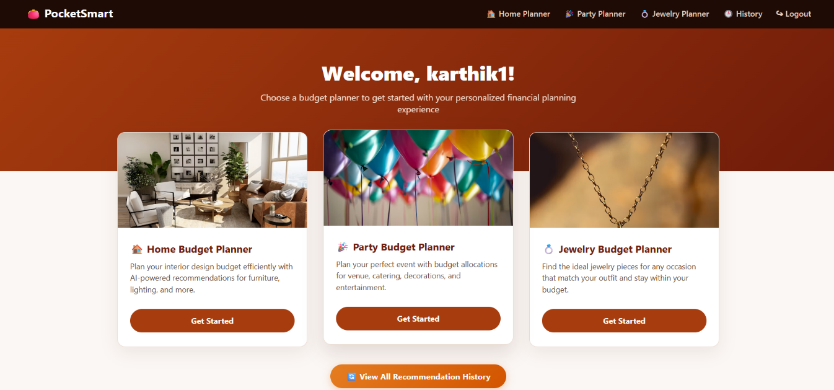

Figure 3: AI-Generated Output & Image Uploads
- Description: Demonstration of the Home interior budget planner accepting an outfit image and rendering customized gemstone recommendations within the user's budget.
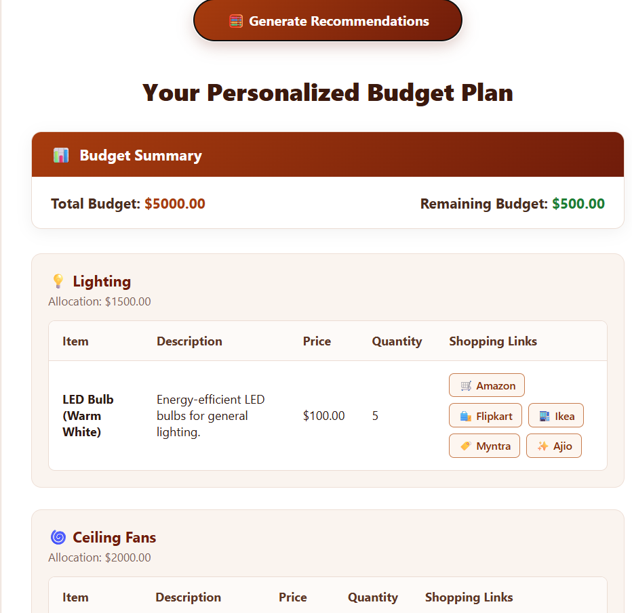
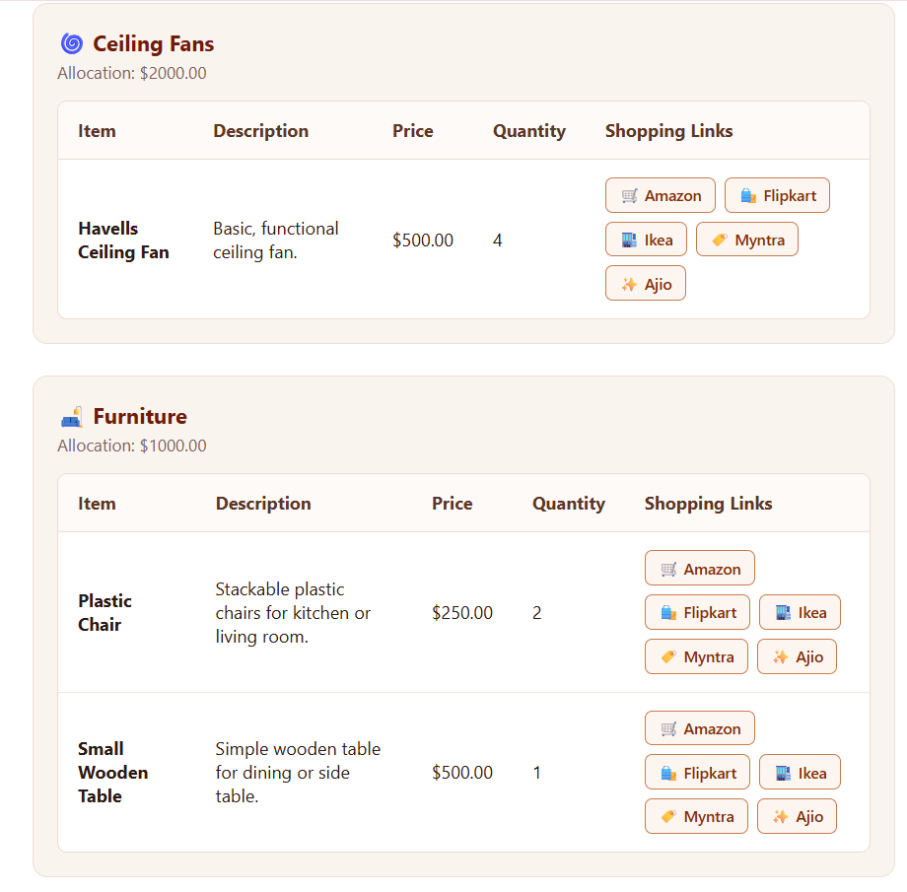

3. Video Walkthrough / Presentation Deck

Video Demo Link: https://drive.google.com/file/d/1-_aqEMjfhSRmq94r6qST18GPCdcdthhK/view?usp=sharing

